

Temporary Food Booth Requirements

Minimum Requirements – All Food Booths

Temporary Food Establishment permit obtained 14 days prior to event and posted at the operating location where it is easily seen. Menu and equipment are present and according to approved plans.
All food is from an approved source:
- prepared in approved commissary and not in a private home, or
- purchased commercially day of event with receipts and/or original packaging available to inspect.
A designated Person In Charge has a valid Washington State Food Worker Card
Restrooms are available for food workers and patrons of the event with stocked and accessible handwashing facilities
Food Booth is constructed properly with:
- Overhead protection
- Approved flooring
- Proper Barriers
Food workers are trained on all requirements and food booth is immediately closed if all safe handling requirements cannot be met at any time, for any reason.
Employee Illness Policy is in place.
Requirements for Food Booths with Temperature Control for Safety (TCS) Foods

Probe thermometer is available, accurate and can be shown to work by the Person In Charge.
All cold holding equipment maintaining TCS foods at 41°F or below.
All hot holding equipment maintaining TCS foods at 135°F or above and provided with continuous power source (Sternos are not allowed) –
- propane or gas burner
- electric steam table
- Grills, BBQs, pit smokers (if allowed by other applicable agencies)
Foods are transported at proper temperature with control and monitoring using cleanable food-grade containers
Handwashing Facilities present, assembled, stocked and accessible.
Hands washed as required (when entering booth, when changing tasks, whenever contaminated, ‘double wash’ after any trip to the bathroom)
Ware washing Facilities for all multi-day events that can support the required wash, rinse, and sanitize of all food contact surfaces that become soiled, contaminated or in-use continuously for more than 4 hours. (3 bin method or approved 3-comp sink)
Ware washing Facilities for single-day events can be 3-bin method or extra utensils (if approved)
Proper barriers to prevent bare hand contact (gloves, tongs, scoops, deli papers, etc.)
A Food-Grade Sanitizer solution (1 teaspoon of bleach per gallon of cold water)

Additional Handling Requirements for Medium and/or High Risk Booths

Commercially purchased pre-cooked foods that are heated must reach 135°F within 30 minutes and maintain 135°F or above until served.
Fresh produce is washed and cut in an approved commissary and placed in a clean food-grade container, OR Purchased pre-washed (receipts, original package available for inspection).
Foods that are found to have been in the Temperature Danger Zone (41F-135F) for more than 2 hours are discarded immediately, AND
Hot held foods are discarded at the end of each day (i.e. cannot cool hot held foods for later re-service)

Additional Handling Requirements for High Risk Booths

Cooking Temperatures of Raw Meats are monitored with an accurate thermometer to ensure proper temps are met:
- Whole Beef, fish, eggs - 145°F
- Pork - 145°F
- Ground Beef - 158°F
- Poultry - 165°F
Foods that are cooked and cooled in advance at the commissary are monitored for rapid cooling:
- A walk-in cooler or commercial, steel-door upright commercial refrigerator is used for cooling hot TCSfoods.
  - Foods are placed in refrigeration for rapid cooling at a food depth no greater than 2 inches, uncovered and in the top of the unit for maximum air flow.
- Ice Bath cooling (or other method alternative to the one above) is achieved using temperature logs and monitoring to ensure:
  - 135°F to 70°F in first 2 hours
  - 70°F to 41°F in remaining 4 hours
- If improper cooling occurs, the food must be discarded.
Foods that were cooked and cooled in advance are reheated (within 30 minutes or less of leaving cold storage) to a minimum temperature of 165°F at the event/in the food booth prior to hot holding or service.
Cross-contamination is prevented during preparation of raw meats by:
- Storing away from ready-to-eat foods; stored separately from different types of raw meats.
- Using separate utensils, cutting boards or storage areas for each type of raw meat and ready-to-eat foods.
- Contaminated surfaces are washed, rinsed, and sanitized before using for another type of raw meat or any ready- to-eat foods.
- An additional container of sanitizer solution and/or wiping cloth is available whenever raw meats arepresent.

Glossary

Approved Plans are determined during your application review – if there are questions or clarifying details in your application regarding the menu and method of preparation, including equipment available at the temporary event, someone from the Health Department will call you to discuss and include notes on that discussion in the permit record so that the inspector can verify onsite. This ensures food safety is maintained and that the inspector can make appropriate corrections to protect consumers at the event.

Approved source of all food items served to the public is one of the most important factors in preventing foodborne illness. Prepared foods that are purchased and used as ingredients in your menu must be from an approved source. If you are preparing foods from scratch for your food booth you will not be able to do any of it in a private home, so a commissary will be required to approve those menu items or allow for them to be sold. FOODS THAT ARE VACUUM-PACKAGED OR “ROP’ED” (REDUCED OXYGEN PACKAGED), ARE NOT ALLOWED TO BE PREPARED OR SOLD UNDER TEMPORARY FOOD BOOTH PERMITS.

Approved commissary is an approved, licensed establishment that is located conveniently to the event and has the space and equipment required to prepare proposed menu items. Commissaries are commonly used for warewashing, fresh produce washing, potable water and wastewater disposal, and overnight storage of food and food equipment for multi-day events. Commissaries are also used for cooking and cooling of foods prior to an event, or other advanced preparation needed for complex menus and will need to have more available commercial refrigeration and space. PRIVATE HOMES ARE NOT APPROVED FOR FOOD STORAGE OR PREPARATION OF ANY FOODS SERVED TO THE PUBLIC. **Commissaries are required for multi-day events unless approval is granted in advanced by Island County Health Department.

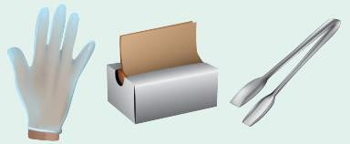
Bare Hand Contact of ready-to-eat foods is a major contributing factor to foodborne illness and is strictly prohibited in temporary food booths. Using a clean utensil to handle ready-to-eat foods is required, and when not possible, a freshly washed hand in a clean single-use glove can be used to handle foods for service.

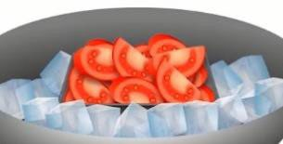
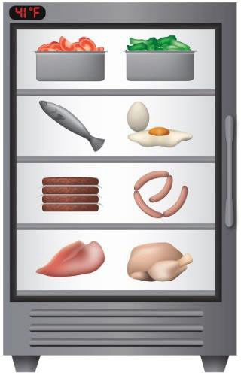
Cold Holding Equipment ensures that temperatures are maintained at or below 41°F, the required maximum temperature for TCS foods while in cold storage to prevent the growth of harmful bacteria in food. Mechanical refrigeration or freezers are strongly recommended, and required when overnight cold holding occurs. Ice chests can be used for cold holding for limited periods of time, and the ice level must meet or exceed the food level within its container, using an accurate thermometer to closely monitor the foods and ensure the ice is sufficient to keep the proper
temperature.

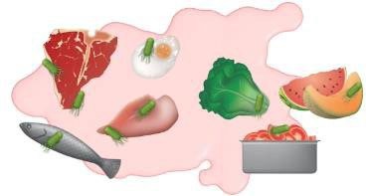
Cross-contamination is a major risk factor of foodborne illness and occurs whenever raw animal proteins come in contact with ready-to-eat foods or other species of raw animal protein. This can happen during storage or preparation and care must be taken to avoid it by:
- Providing enough storage space to keep all raw meats separated and in closed containers below and away from other types of food.
- Preparing raw meats in a separate area using separate utensils at different timesthan when ready-to-eat foods are handled or prepared.

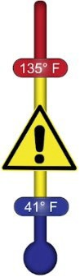
Danger Zone refers to a temperature between 41°F and 135°F where bacteria can rapidly grow to harmful levels. TCS Foods are not allowed to be stored in this temperature range and care must be taken to monitor foods to ensure it is avoided and corrected whenever necessary (by rapidly reheating or discarding foods right away). Review our Food Safety Temperatures Guide .

Employee Illness Policy is a requirement for all temporary food booth operators to ensure that food workers are informed of the restrictions that must be enforced should they experience symptoms of foodborne illness. The policy must train food workers on the following symptoms, and require them to notify their Person In Charge and be excluded from food handling if experienced:

Symptoms of a Gastrointestinal Infection such as diarrhea, vomiting or jaundice (yellow skin or eyes) unless they have written medical documentation that the symptom is due to a medical condition not transmissible through food.
- Sore Throat with Fever
- A lesion containing pus, such as a boil or infected wound that is open or draining and is:
  - On the hand or wrist.
  - On exposed portions of the arms.
  - On other parts of the body, unless the lesion is covered by a dry, durable tight-fitting bandage.
- A Diagnosed Illness from Norovirus, Hepatitis A, Salmonella, Shigella, and Shiga toxin-producing E.coli.


Food Booth Construction should be done with non-absorbent, durable, and easy-to-clean materials and include:
- Overhead protection: located indoors; canopy or permanent structure required outdoors.
- Approved flooring: booths set up outdoors on porous ground (dirt, grass, gravel) must provide an approved floor surface (tarp, mats).
- Proper Barriers: food preparation areas are separated from areas of public access; grills or hot equipment has at least 4 feet of separation from public access; displayed food protected via a sneezeguard, original packaging or other physical barrier; Condiments not in individual packages are provided in dispenser bottle or in other containers protected from contamination.

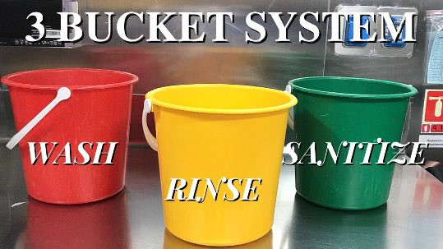
Food Contact Surfaces include all food containers, utensils, single-use gloves, and preparation surfaces such as cutting boards or service platters. They must be smooth, non-absorbent, durable, and easy to clean. If continuously used for TCS foods during an event, they need to be washed, rinsed, and sanitized every 4 hours or as they are contaminated, whichever happens first. If surfaces are used for storage or preparation of shelf stable (non-TCS) foods, only they should be washed, rinsed and sanitized every 24 hours or as they are contaminated. Non-food surfaces should be maintained and kept clean.


Food-Grade Sanitizer should be in all food booths with open foods to keep food-contact surfaces clean. Care should be taken to ensure the solution is mixed to a food-grade concentration so that food is not contaminated by chemicals that are too strong:
  - Bleach sanitizer: 1 teaspoon of bleach to a gallon of cool water that is changed out whenever it becomes cloudy or dirty.
  - Quaternary ammonium sanitizer: Follow the manufacturer’s label to ensure it is mixed properly.
Rinse and store wiping cloths in the sanitizer bucket between uses.

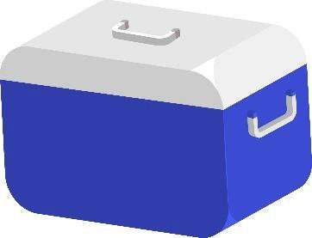
Food Transportation should be carefully considered whenever TCS foods are brought to the event. The vehicle used to transport should be clean, and insulated containers with ice packs or a heating element should be used to maintain temperature control below 41°F or above 135°F. All ready-to-eat foods should be stored and transported in clean, food-grade containers.

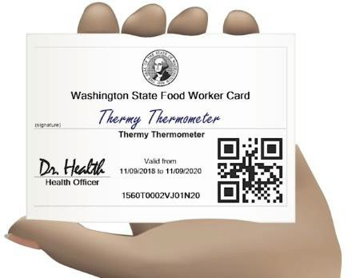
Food Worker Training is an important part of preventing food borne illness. In addition to your illness policy, expectations for proper handwashing, prevention of bare hand contact and proper cooking and holding temperatures should be set and taught to all food workers at your booth for the whole event. Food worker cards are only required for one Person In Charge at each booth but are strongly recommended for all food workers present.

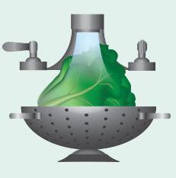
Fresh Produce must be washed in an approved commissary prior to being cut and otherwise prepared for temporary food booths. On-site washing of produce is only possible if a dedicated, pre-approved food preparation sink is on-site and available for your use. Cutting fresh produce is also not allowed in food booths except in very limited, pre-approved capacities. If a commissary is not available, pre-washed and cut produce must be purchased and used.

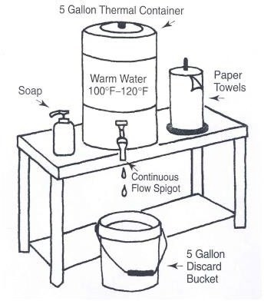
Handwashing Facilities are required for all food establishments handling open foods, and must be conveniently located, stocked with warm water between 100°F and 120°F, soap and paper towels, an approved wastewater conveyance, and accessible for all staff to use frequently as required. Bathroom facilities must have dedicated handwashing facilities, and all food booths must have their own handwashing station set up within the booth.

FOOD BOOTHS WITHOUT AN ADEQUATELY STOCKED AND DEDICATED HANDWASHING SINK WILL NOT BE ABLE TO OPERATE IF HANDLING OPEN FOOD.

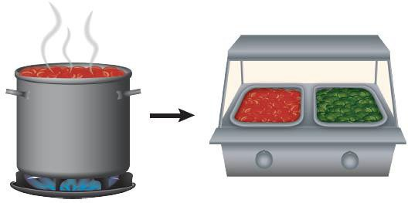
Hot Holding Equipment ensures that temperatures are maintained at or above 135°F, which is the required minimum temperature for holding fully cooked or reheated TCS foods to prevent the growth of harmful bacteria.
Hot holding equipment must be mechanically powered and used only for hot holding foods that have already been thoroughly reheated or fully cooked (STERNOS ARE NOT ALLOWED). Ensure that the stove, burner, grill, hot plate, or steam table will be allowed at your event location and approved by the local fire district.


Thermometer is an essential piece of equipment for any food booth and should meet the needs of your menu and food preparation steps. An accurate thermometer is required for all food establishments that handle or store TCS foods. For those that are cooking meats from raw or heating thing foods to hold hot or immediately serve, a digital thin-probe thermometer will be required. These thermometers should be calibrated to within 2°F or less and have plenty of battery power to reliably read temperatures throughout the event.

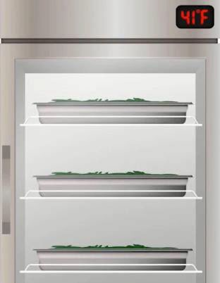
Rapid Cooling must be achieved for any TCS food that is cooked and cooled in advance. This can be supported by placing foods into a commercial refrigeration unit at a food-depth of 2-inches or less uncovered or using an ice bath and monitoring the process with an accurate food thermometer.

COOLING IS NOT PERMITTED IN ANY FOOD BOOTH OR MOBILE FOOD UNIT AND MUST BE DONE AT A COMMISSARY AHEAD OF THE EVENT.


Step 1: Cool food, uncovered, within 2 hours, from 135°F to 70°F
Step 2: Then cool, within a total of 6 hours, to 41°F

Ware washing Facilities are required for all food booths that operate for more than one day or that have food-contact surfaces that will be reused throughout the event. It is a minimum requirement that food surfaces are:
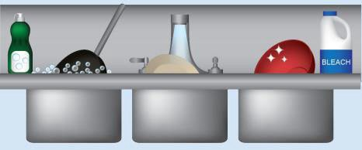
- Washed with soap to remove all food debris or contaminants.
- Rinsed with clean water.
- Sanitized with a food-grade sanitizer and air dried in a clean environment.
This can be achieved by a plumbed 3-compartment sink on-site or using the 3- bucket method and supplied with water from an approved source and wastewater conveyance.

