Donated Food Distributing Organization
APPLICATION TYPE (Check applicable box) ◻ New DFDO ◻ Annual Update
- Food Bank | - Food Pantry
- Home Delivery | - Meal Program where food is prepared offsite
- Meal Program where food is prepared on site, such as a Soup kitchen or community meal | - Other: ____________________________________

DFDO INFORMATION
DFDO name |  | DFDO phone
Physical address City |  | Email Address
Mailing address City State Zip code

Unified Business Identifier (UBI #) | Intended date of opening or when changes will go into effect | Total # meals/families served:
Day & Times of operation: |  | Do you have a 501 (C) IRS determination letter?  ◻ Yes (attach if New application) ◻ No

DFDO OWNER INFORMATION
Ownership Name
Food DFDO owned by:
◻ Individual ◻ Corporation ◻ Association ◻ Partnership ◻ Non-profit ◻ Other
Applicant / Contact First and last name and Title Phone number Email address
Mailing address City State Zip code
If there are multiple owners, list the other owners’ names here. The main owner who will be our point of contact should be the one listed above.
If partnership, corporation or LLC, attach list of all partners or corporate officers as registered with the State of Washington.

Any changes in food service activities/facility? ◻ No ◻ Yes, If yes, explain: ______________________________________

CERTIFICATION AND ACKNOWLEDGMENT
* I have read and agree with the requirements of WAC 246-215 and to notify the Island County Health Department annually of the nature of food service activities, including types of food served or distributed or whenever there is a significant change in food service activities or location of activities. Notification will be made immediately, in writing, of any change of mailing address, ownership, 501c3 status or change in operation. Inspections will be allowed in accordance with WAC 246-215.
Owner/ Applicant name printed Owner/ Applicant signature Date

**Annual update stop here – New establishment continue with all pages**

DFDO Questionnaire

- ☐ Yes ☐ No – Does your facility have separate handwashing sink stocked with soap and paper towels?

- ☐ Yes ☐ No - Does your facility have a bathroom with running hot/cold water and a hand washing sink?

- ☐ Yes ☐ No - I will verify that any raw meat accepted at this facility is from an approved source. If I accept any game meats, livestock, or otherwise uninspected raw meat. I will ensure that I follow all special labeling and handling requirements as specified in Washington State Food Code 09415.

- ☐ Yes ☐ No - All packaged TCS foods will be stored either in a freezer or refrigerator that maintains the food at a temperature of 41°F or below.

- ☐ Yes ☐ No - When receiving TCS foods, I will verify the temperature upon arrival to be below 41°F or above 135°F. I will maintain these temperatures throughout service OR I will serve all food immediately upon receipt and discard any leftovers.

- ☐ Yes ☐ No - When transporting TCS foods, I will maintain food below 41°F or above 135°F by using ice chests, insulated containers, or some type of electrical temperature control equipment. I will use a thermometer to verify the temperature.

- ☐ Yes ☐ No –I will not accept any TCS foods that are in the temperature danger zone (41°F to 135°F).

- ☐ Yes ☐ No - I will not re-serve any unpackaged foods that has been previously served to someone else.

- ☐ Yes ☐ No – If I repackage bulk foods in my facility, I will ensure the common name of the food, allergen statements, name and location of the food distributor or processor are written on each container label. I will maintain the complete label information for any repackaged food and ensure it is clearly displayed.

- ☐ Yes ☐ No –If I receive donated, non-commercially packaged TCS foods or ready to eat foods, I will keep records for 90 days documenting the source, quantity, type, and receiving date.

- ☐ Yes ☐ No –I will use a calibrated thermometer to verify final cooking temperatures of all meats I cook from raw to ensure that: raw beef, pork and seafood are cooked to at least 145°F; raw ground pork, beef and seafood are cooked to at least 158°F; raw poultry, stuffed meat and game meat is cooked to at least 165°F.

- ☐ Yes ☐ No –I will wash, rinse and sanitize any food contact surfaces used for preparing and serving TCS foods in a 3-compartment sink or dishwasher after each use or every 4 hours (this does not include serving utensils that are stored in temperature-controlled food or scoops/containers used for handling shelf-stable items).

- ☐ Yes ☐ No – All donated hot foods or hot foods prepared at this facility will be held and served at 135°F or above (verified with thermometer). If hot food falls below 135°F, the food will be reheated to 165°F quickly.

- ☐ Yes ☐ No –I will immediately discard any TCS foods that have been held at my facility in the temperature danger zone (41°F to 135°F) for more than 4 hours.

- ☐ Yes ☐ No –If providing meal service, all produce served will be washed in a clean sink as defined in Washington State Food Code 09410(5).

- ☐ Yes ☐ No –I will cool hot foods from 135 °F to 41 °F in 6 hours or less, provided that the food has reached 70 °F within the first 2 hours. I will use an ice bath or commercial refrigeration equipment for cooling and verify all cooling temperatures with a thermometer.

- ☐ Yes ☐ No –I will store and handle raw meats below or away from ready to eat foods. I will wash, rinse and sanitize any surfaces immediately after contact with raw meat.

- ☐ Yes ☐ No –All refrigerated, ready to eat foods that are TCS, will be date marked with the preparation date/opening date and discarded within 7 days.

- ☐ Yes ☐ No –All cooled TCS foods received from a donor kitchen or Food Establishment will be reheated to at least 165F within 2 hours.

- ☐ Yes ☐ No – Refuse, recyclables, and returnable are stored in a manner that does not create a public health hazard or nuisance.

- ☐ Yes ☐ No – Children under ten and animals are kept out of the food preparation areas.

- ☐ Yes ☐ No – Toxic chemicals are in properly labeled containers and stored away from food and food service supplies.

- ☐ Yes ☐ No – Vehicles owned and operated by the Donated Food Distributing Organization for transporting food are cleaned at a frequency necessary to prevent accumulation of soil residues. The interior of the vehicle where food containers are stored must be clean and free of insects, dirt, animals, leakage, and other potential contaminants.

- ☐ Yes ☐ No –I understand that I may not accept, serve, or distribute:
  - Home-canned foods;
  - Foods from a residential kitchen in a private home, other than those specified in 09415;
  - Foods from a donor kitchen prepared using specialized processing methods as described in 03535;
  - Canned foods in containers that are rusty or severely damaged;
  - Distressed foods (such as from a fire, flood, or prolonged storage) unless the foods have been evaluated and approved for charitable distribution;
  - Infant formula that is past the original expiration date set by the processor; or
  - Raw, unpasteurized milk

- Please list all your food vendors:

DETAILED PLAN REQUIREMENTS
Facility Site plan - Include all areas of the food service establishment on a site plan. All text on the site plan must be legible. Be sure to include the following for indoor and outdoor areas:
- Restroom locations
- Seating areas and banquet rooms
- Approximate locations of tables and chairs
- Server stations
- Bar
- Bussing stations
- All storage and food preparation areas
- Off-site storage or preparation facilities
Kitchen Floor plan - Include food storage, preparation, and service areas. Include enough detail to clearly show all equipment, fixtures, work areas, storage areas, etc. All items must be drawn to scale.
Equipment and sink requirements depend on menu and food prep methods. Be sure to include:
- Plans drawn to scale. Minimum scale ¼” = 1’ (¼ inch on the floor plan equals one foot in the food establishment).
- Manufacturer name and model number for each piece of equipment.
- A utensil cleaning area with sinks. A three-compartment sink is required. Include drain boards for both soiled and clean utensils. Provide dimensions of sink basins and drain boards.
- Dish machine (optional). Dish machines must be commercial style with a chemical or high temperature rinse cycle. Commercial dish machines usually complete a full cycle within 5 minutes.
- Handwashing sink(s). Must be located convenient to food preparation, service, and ware washing areas. Handwashing sinks must be plumbed with warm and cold water.
- Produce and ready-to-eat food preparation work station with sink. Show dimensions of sink.
- Raw meat and raw seafood preparation work station with sink. Show dimensions of sink.
- Water filtration and treatment systems if applicable. Systems must meet appropriate ANSI-NSF standards for potable water.*
- Indirect floor sink and hub drains. Indirect drainage is required for food preparation sinks, dish machines, ice machines, ice storage bins, cooler condensate, dip wells. *
- Cooking equipment. Proper ventilation is required – contact your local building department. *
- Refrigeration – must be commercial style. Refrigeration capacity must be adequate to support proposed menu and preparation methods. *
- Freezers *
- Hot food holding equipment. *
- Miscellaneous equipment. For example, mixer, blender, slicer, food processor, ice machine, soda fountain, milkshake machine, work tables, etc. *
- Dry storage shelving - must be smooth, durable and easily cleanable.
- Hot water heater - make, model number, and capacity.
- Equipment schedule indexed to floor plan. See sample floor plan.

*Only commercial equipment that meets National Sanitation Foundation (NSF) standards or equipment will be accepted.
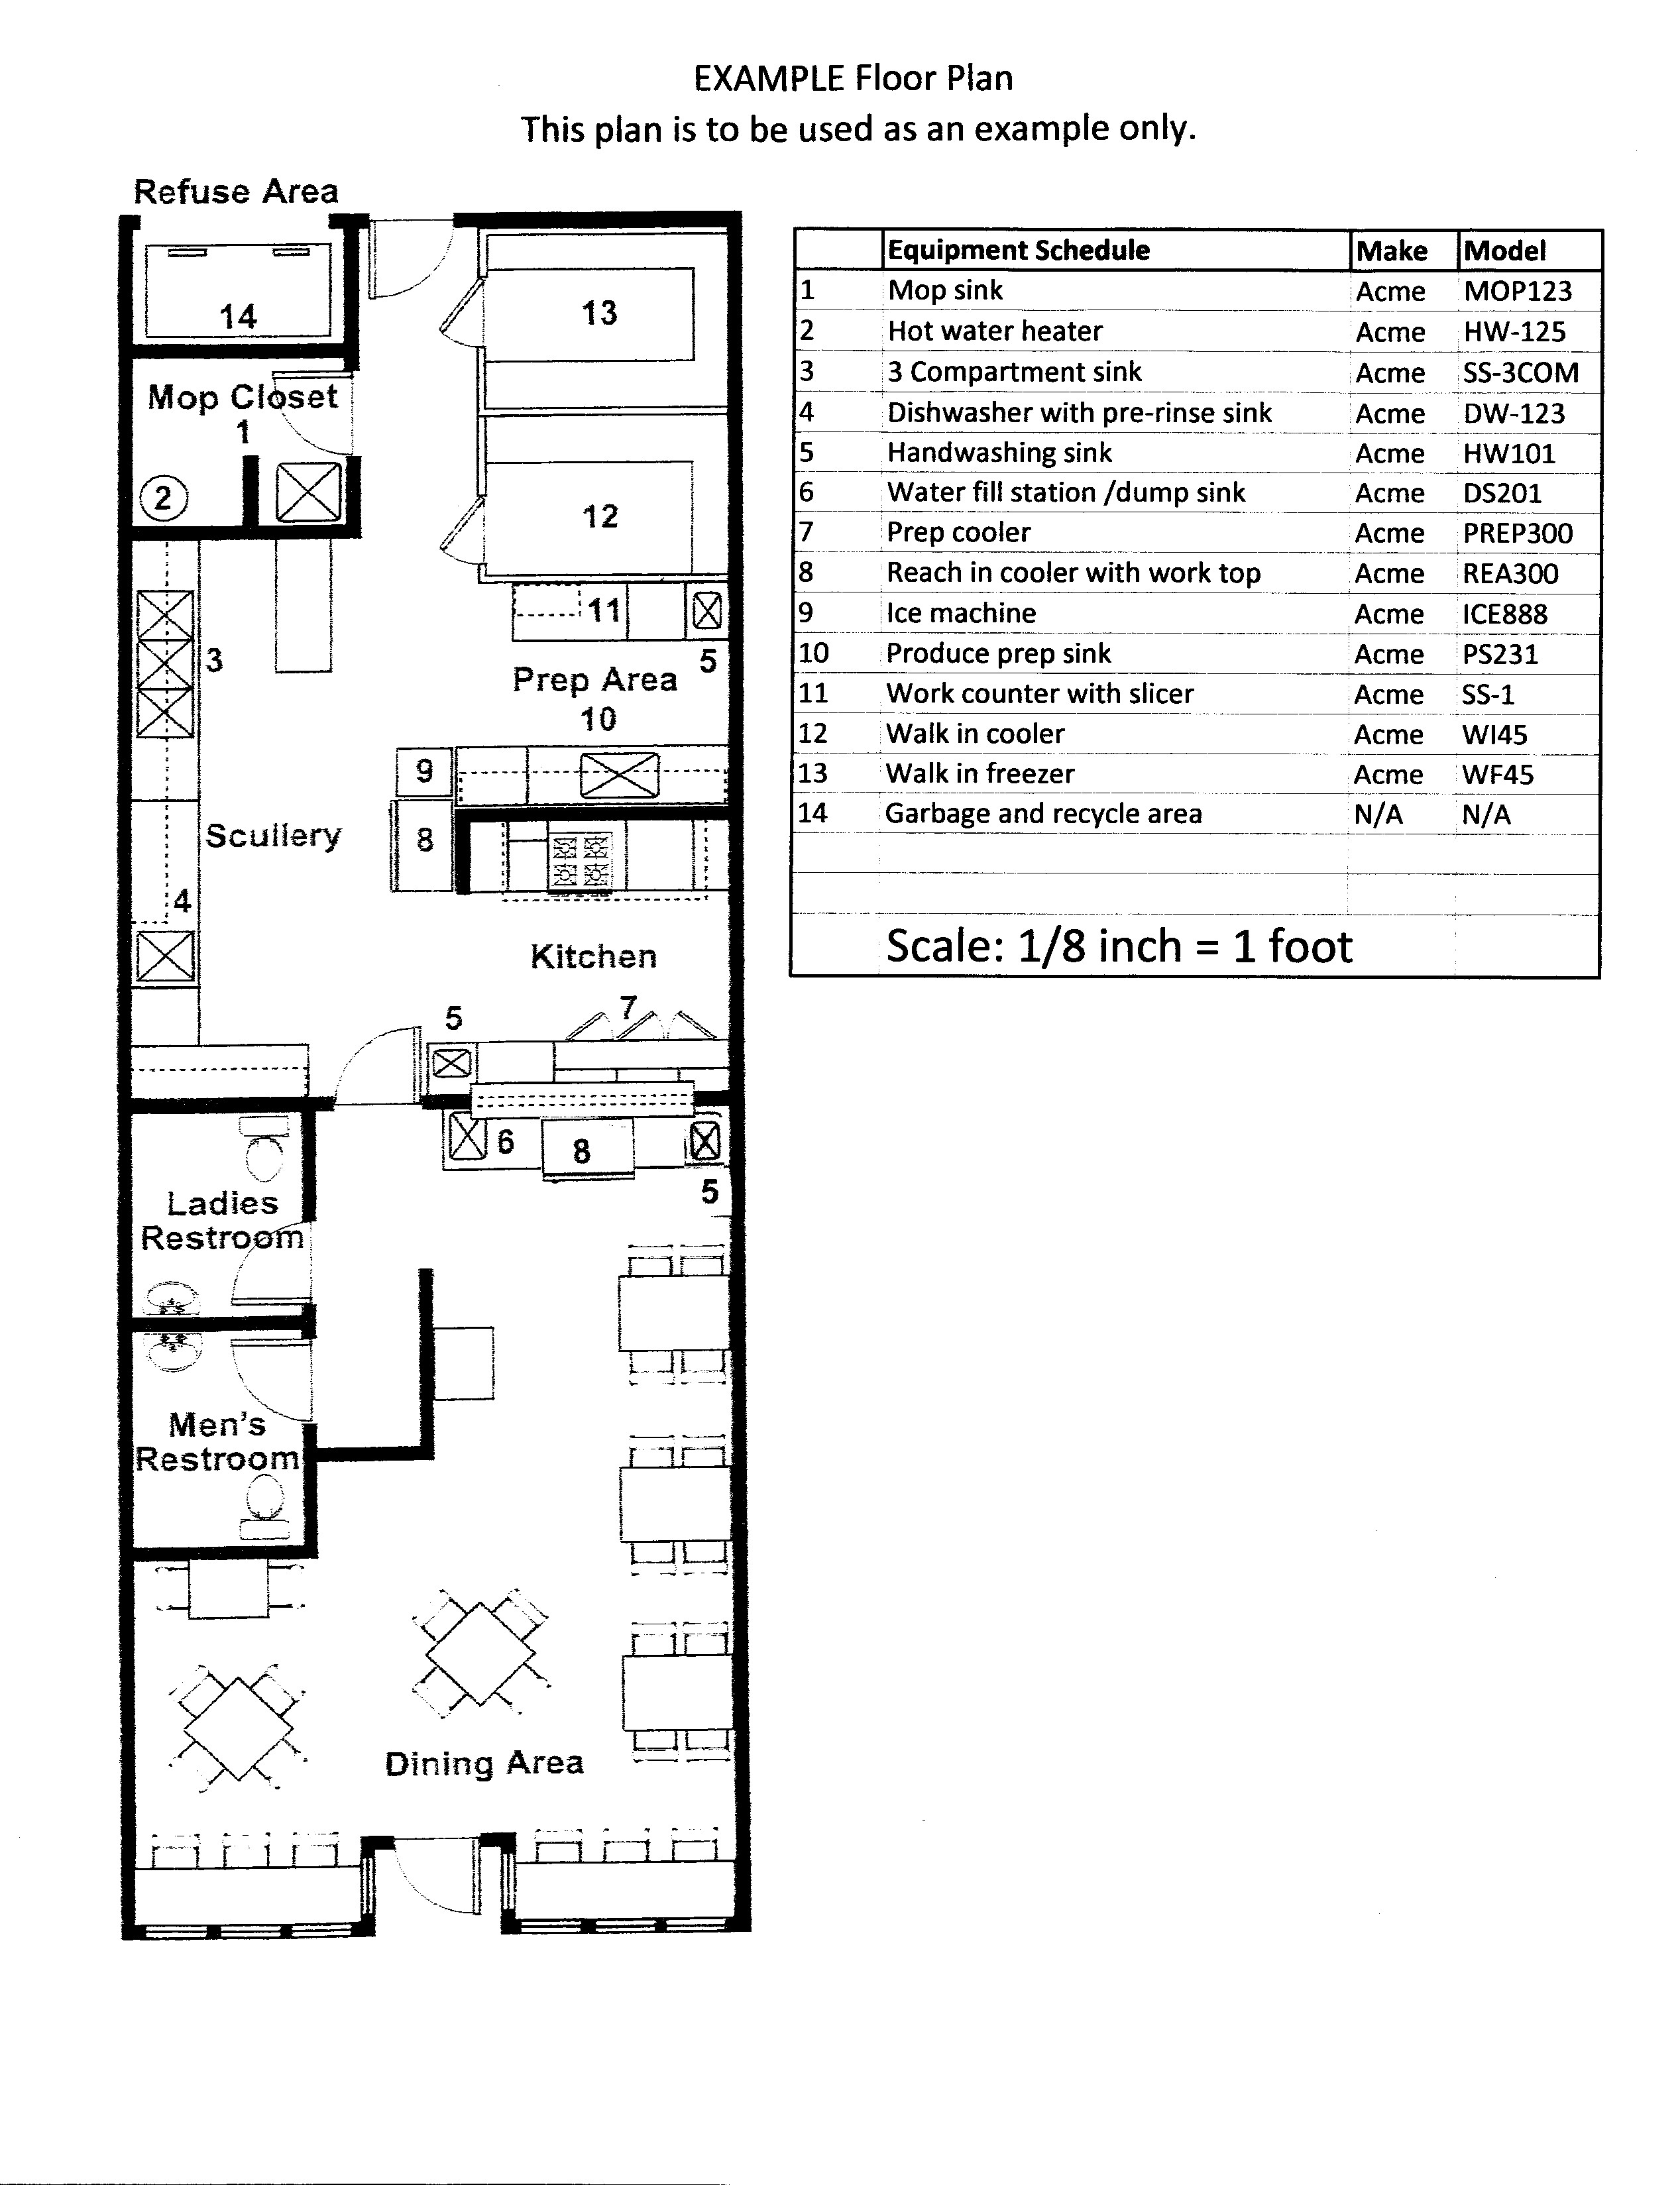

Food Equipment List
If not included in professionally drawn plans, list all food service equipment including make, model number, and quantity. Submit an equipment specification sheet with corresponding identification number included on the top right corner of the specification sheet. Equipment examples include but are not limited to refrigerators, sinks, stoves, ovens, steam tables, blenders, ice machines, ventilation hoods, hot water heaters, countertop appliances, etc. If a make and model number cannot be found, a picture of the equipment is required. All equipment ID numbers must correspond to location on floor plan.

Sample Equipment List
ID # | Equipment Description | Make | Model | Qty.
1 | Hand Wash Sink | Regency | 600HS172EFW4 | 1
2 | Three Compartment Sink | Regency | 600S321824X | 1
3 | Hot Water Heater | AO Smith | DEL-30 | 1
4 | Single Door Reach in Refrigerator | Beverage Air | RB27HC-1S | 2
5 | Sandwich Prep Table | Beverage Air | SPED72HC-30M-2 | 1
6 | Two Door Reach in Freezer | Beverage Air | FB49HC-1S | 1
7 | Convection Oven | Vulcan | VC5E | 1
8 | Fryer | Frymaster | GF14 | 3
9 | Hood | CaptiveAire | ND-2 | 1
10 | Coffee Maker | Bunn | 53100.0000 | 1
11 | Blender | Waring | CB15 | 2

Equipment Sanitation Standards

Equipment must be commercial grade and meet American National Standards Institutes (ANSI) standards or equivalent.

Sample Sanitation Certification Marks

The below agencies are accredited by ANSI as a Certification Body (ISO/IEC 17065)

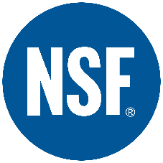

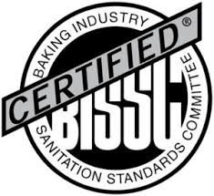
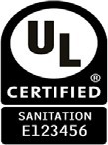

Food Equipment List

Food Establishment Name: __________________________________________________________________

Equipment List

ID # | Equipment Description | Make | Model | Qty.
 | Water Heater
 | 3 Compartment Sink
 | Hand Wash Sink

