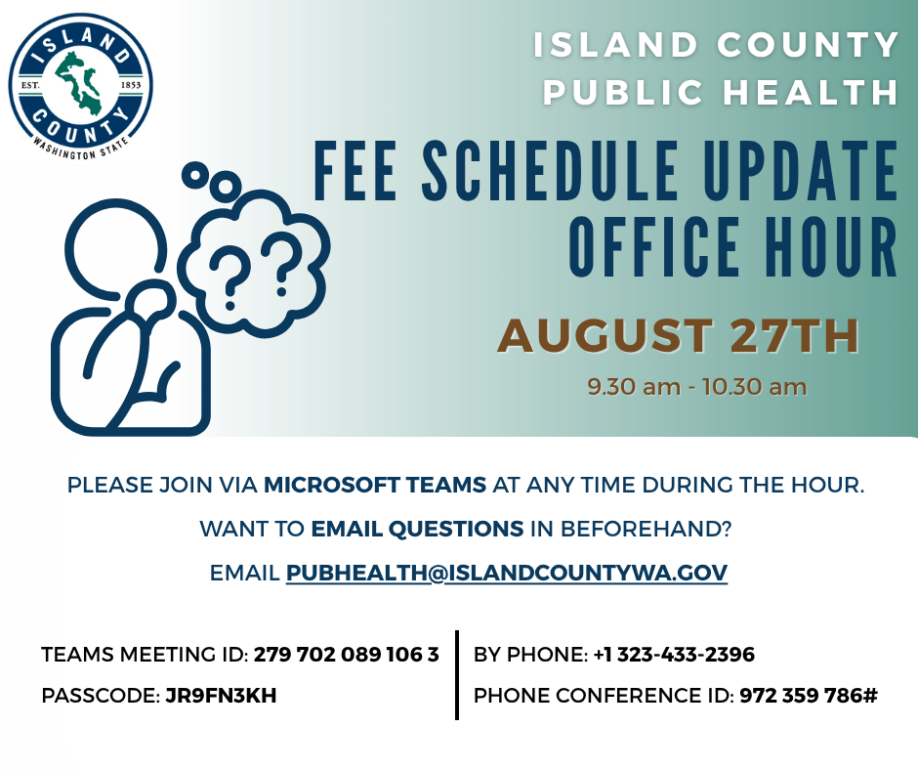

SUMMARY

The session focused on the proposed 2026 fee schedule, with an acknowledgment addressing the low attendance attributed to the busy restaurant season.

A client sought clarification on what constitutes a major menu change requiring a plan review, to which Food Inspector Todd Appel provided examples, emphasizing that significant alterations in cooking processes or temperature handling would necessitate a review, while minor menu variations would not. This discussion highlighted the importance for food establishments to remain aware of regulatory changes and their implications.

Additionally, interest was expressed in collaborating on farmers' markets and farm stands, while Director Shawn Morris noted that the fee update aims for equitable distribution rather than increased revenue, leading to an explanation of the new risk-based fee structure for temporary food establishments. There was also confirmation that Public Health is expanding options by adding recurring event permits, which will decrease costs for vendors, and better facilitate the permitting process between Planning and Public Health for special events.

A question was asked about the permits needed for hosting multiple seasonal events at a farm, with Todd clarifying that food vendors require temporary food licenses and the farm needs a coordinator's license. The challenges of engaging with farmers and food producers during their busy season were discussed, emphasizing the need for their feedback. Shawn reiterated the importance of ongoing communication and potential adjustments based on industry insights.

